Updates of Linear charger in Dec 2018

Updates of Buck in Dec 2018
- Criteria
- Catalog
Power management >> Stepdown(Buck) >> Integrated switch(IC)
- Vin
Vin_min ≤ 9
Vin_max ≥ 20V
- Vout
Vout_min ≤ 9
Vout_max ≥ 9.5V
- Iout
200mA ≤ Iout ≤ 3A
- Channels
1
- Mode
- Efficiency
η ≥ 90% @ 200mA
η ≥ 80% @ 10mA
η ≥ 50% @ 1mA
- Iq
Iq ≤ 0.1mA
- Features
Enable
Light load efficiency
Synchronous Rectification
Current limiter: 200mA-500mA
- Package
- Price
Price ≤ $1 @1000 pieces
- Comparison

Part No. | Vin | Vout | Iout | η | Iq | I lim | Feature | Pkg | Price
TPS54061 | √ | √ | √ | √ | √ | √ | √
TPS560430 | √ | √ | √ | × | √ | × | √
TPS54202 | √ | √ | √ | √ | √ | × | √
TPS54202H | √ | √ | √ | √ | √ | × | √
TPS56339 | √ | √ | √ | √ | √ | × | √
TPS54335-1A | √ | √ | √ | × | × | × | √
TPS54334 | √ | √ | √ | × | × | × | √
TPS54336A | √ | √ | √ | × | × | × | √
TPS54335A | √ | √ | √ | × | × | × | √
TPS54335-2A | √ | √ | √ | × | × | × | √
TPS54302 | √ | √ | √ | √√ | √ | × | √

Schematics of control circuitry

- PlanI
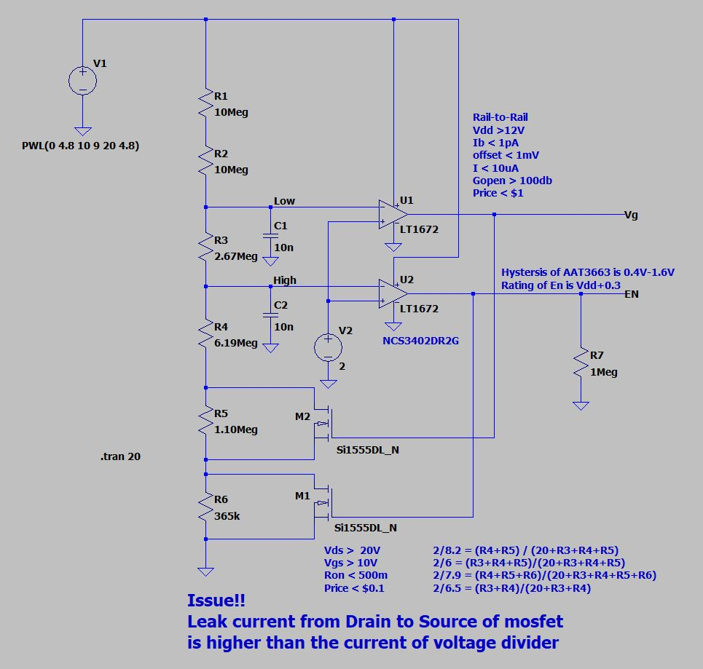
- PlanII
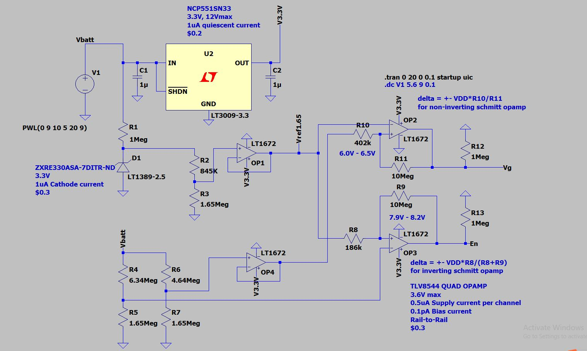
- BuckConceptral
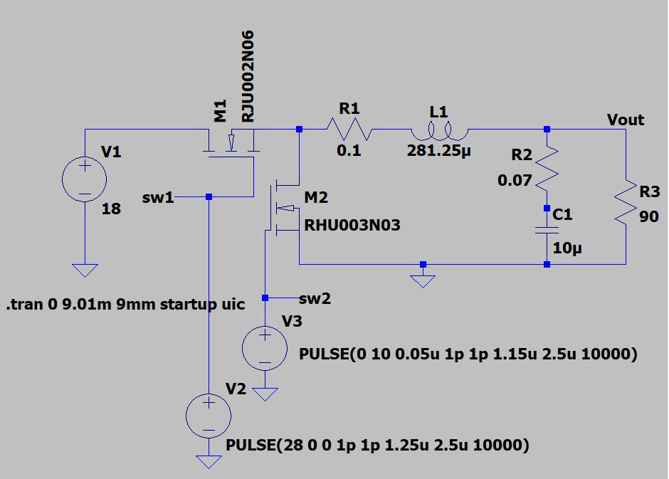

Simulation of control circuitry
- MarcPlan.asc
- MyPlan.asc
- BuckConceptral.asc

Parameter calculation
- PlanI
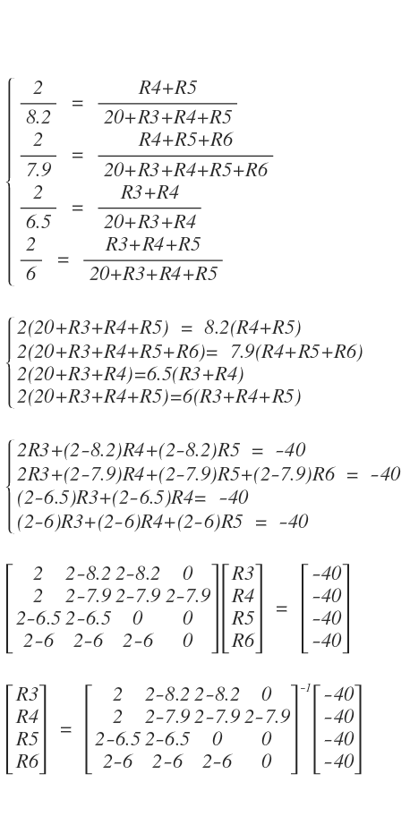

Reference: ResistanceCal.m

- PlanII
- For 7.9-8.2 Schmitt
∆= ± Vbatt * R8 / (R8 + R9)
= ± 8.05V * 186k / (10Meg + 186k)
≈ ± 0.15V
∆= ± Vbatt * R10 / R11
= ± 6.25V *402k / 10Meg
≈ ±0.25V
- For Voltage divider
Vref_u = R5 / (R4+R5) * Vbatt
= 1.65Meg / (1.65Meg + 6.34Meg) * 8.05V
≈ 1.65V
Vref_l = R7 / (R6+R7) * Vbatt
= 1.65Meg / (1.65Meg + 4.64Meg) * 6.25V
≈ 1.65V
- Buck
TPS54061_Cal.ods
- Linear Charger
TPS54061_Cal.ods

Test result
- Functional test
Situation: 20mA regular load, switch on/off @ ground line by N-FET,
Schmitt @ 7.9V-8.2V: around 7.9V~8.15
Schmitt @ 7.75V-7.85V: around 7.794V~7.887V
Schmitt delay @1uF 100k, @ 7.75V-7.85V : 10ms
Schmitt @ 6.0V-6.5V: around 6.05V ~ 6.55V
Alkaline charging: Yes, 100mA max
Solar Panel charging: Yes, around 20mA
Quiescent current:
- Control Circuitry
- PlanI
Issue: Leakage current from drain to source of N-MOSFET is 1uA typically. It is even higher than the current of voltage divider.
- PlanII
- Schmitt trigger 7.9-8.2: 7.88~8.18V
- Schmitt trigger 6.0-6.5: 6.07V~6.6V
- Current: 8uA~16uA
- Buck
- Functional
200mA shut down: 190mA~200mA
enable: yes
UVLO: n/a
f_sw: 400kHz
duty: around 50%
- Vin & Vout
Vin RMS: 16V
Vin ripple: 100mV
- Ripple
Vout_ripple @ 100mA: 70mV
Vout_ripple @ 10mA: 70mV
Vout_ripple @ 1mA:
Iout_ripple @ 100mA:
Iout_ripple @ 10mA
Iout_ripple @ 1mA:
- Efficiency
η @ 100mA: 8.94V*100mA/ 17.997V / 53.3mA = 93.2%
η @ 10mA: 8.94V*10mA/17.997V/5.9mA = 84%
η @ 1mA: 8.94V*1mA/17.997V/1.4mA = 35.7%
- Transient load
Light load (0A) > high load(170mA): 1200mV, 1ms
High load(170mA) > light load(0A): 600mV, 40ms
- f-domain close loop response
- short: 58mV
- Thermal
No perceptible heat
- Quiescent current (disabled): <22uA

- Linear Charger
- Functional
Charging current: around 100mA
- Efficiency:
Input current: 104.8mA, Charging current 99.9mA @ 7.3V Battery R4=1k
Input current 102.8mA, Charging current 100mA @ Vbatt=7.5V R4=900k
Input current 2.3mA, Charging current 4uA @ Vbatt=8.1V R4=900k
Input current ?mA, Charging current ?uA @ Vbatt=5.4V R4=900k
- Over & Under charging
- Voltage on CC
5.9 on, 8.84 off @R4=1k
5.9 on, 8.83 off @R4=900k
The datasheets of BQ2057 says the sinking current of CC pin is at least 5 mA.
Actually, the pull up of open-drain can be 1Meg.
- Thermal
No perceptible heat
- Temperature of Battery
No perceptible heat
- Quiescent current (no bat attached): 23uA max

